Департамент образования и науки города Москвы

Государственное автономное образовательное учреждение

высшего образования города Москвы

«Московский городской педагогический университет»

Институт цифрового образования

Департамент информатики управления и технологий

Агафонов Антон Александрович БД-241м

## **Практическая работа 2. Изучение методов хранения данных на основе NoSQL Cassandra**

Направление подготовки/специальность

38.04.05 - Бизнес-информатика

Бизнес-аналитика и большие данные

(очная форма обучения)

ФИО преподавателя

Босенко Тимур Муртазович

Вариант 1

Москва

2025

Цель работы: получить практические навыки работы с базой данных Cassandra, изучив основные операции по управлению данными, включая создание и использование ключспейсов, таблиц, выполнение запросов CQL, а также работу с различными инструментами подключения и администрирования.

Ход работы

Запускаем Cassandra

**Sudo docker compose start**

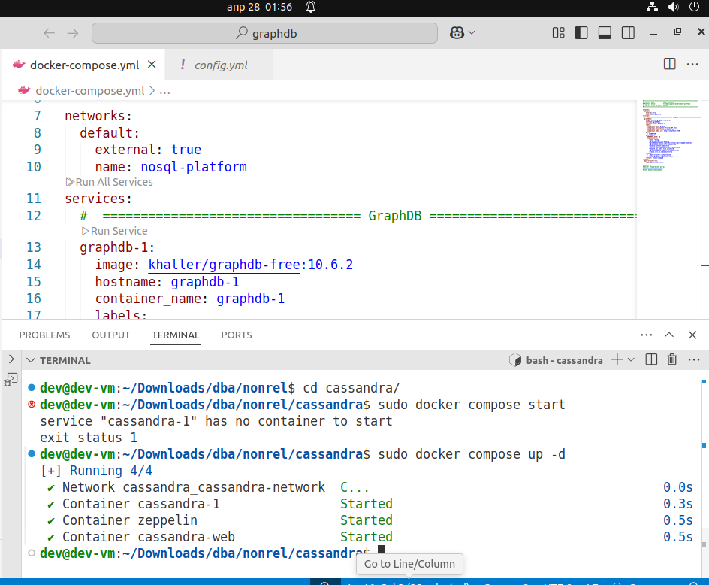

Рис.1 Запуск кассандры

Проверяем запущенные сервисы 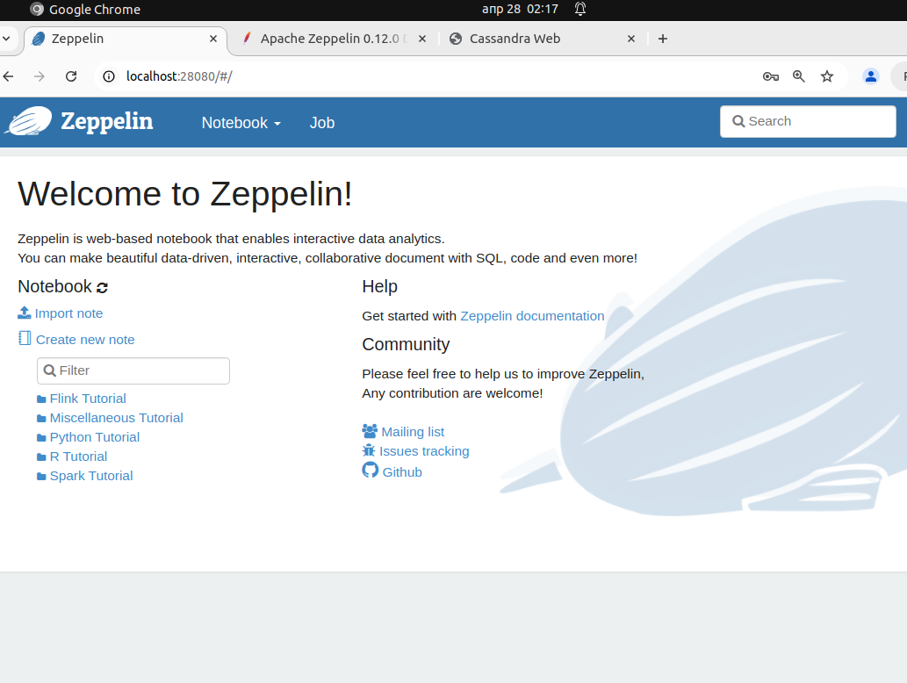

Рис.2 Проверка zeppelin

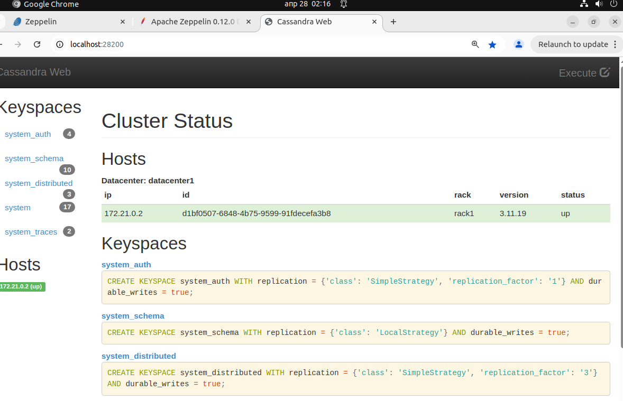

Рис.3 Проверка Cassandra web

Создали запись в кассандре

Рис.4 создание записи

Просматриваем существующие в настоящее время пространства ключей

**SELECT * FROM system_schema.keyspaces;**

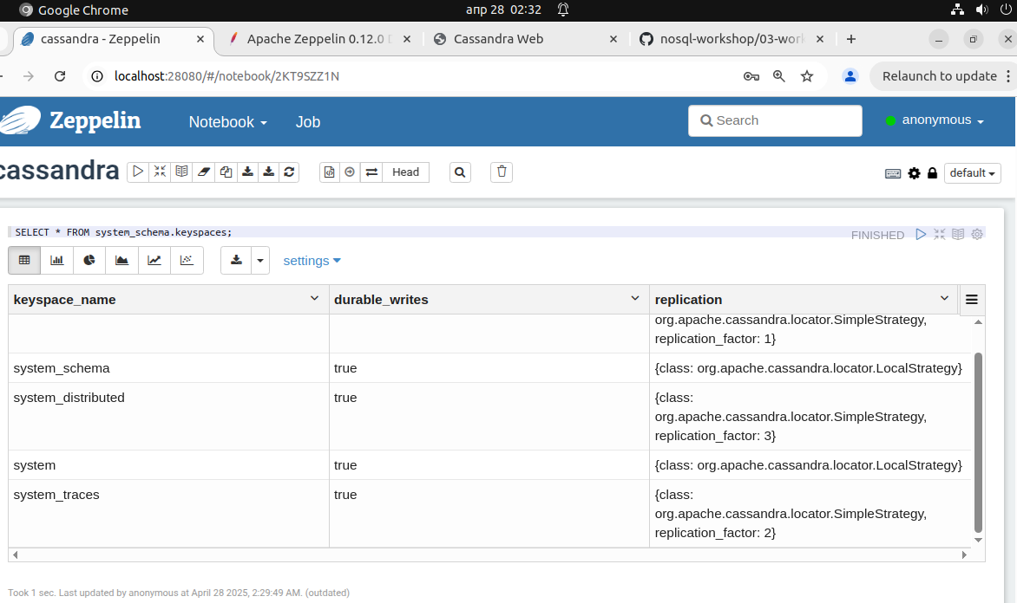

Рис.5 Пространства ключей

**CREATE KEYSPACE movies WITH replication =**

**{'class':'SimpleStrategy','replication_factor':1};**

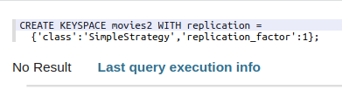

Рис.6 создали новое пространство ключа

Создадим таблицы movie и actor

**DROP TABLE IF EXISTS movies.movie;**

**CREATE TABLE movies.movie (movie_id int,**

**title text, // title**

**release_year int, // year**

**running_time int, // runtimes**

**languages set<text>, // language codes**

**genres set<text>, // genres**

**plot_outline text, // plot outline**

**cover_url text, // cover url**

**top250_rank int, // top 250 rank**

**PRIMARY KEY (movie_id)**

**);**

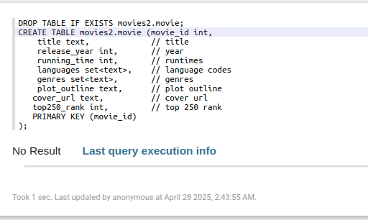

Рис.7 Создание таблицы movie2

**DROP TABLE IF EXISTS movies.actor;**

**CREATE TABLE movies.actor (actor_id int,**

**name text, // name**

**headshot_url text, // headshot**

**mini_biography text, // mini biography**

**birth_date text, // birth date**

**trade_mark list<text>, // trade mark**

**PRIMARY KEY (actor_id)**

**);**

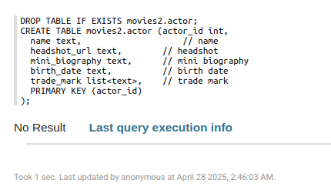

Рис.8 Создание таблицы actor

Добавим фильмы "Матрица" и "Криминальное чтиво"

// insert "The Matrix" - 0133093

INSERT INTO movies.movie (movie_id, title, release_year, running_time, languages,

genres, plot_outline, cover_url, top250_rank)

VALUES (0133093,

'The Matrix',

1999,

136,

{'en'},

{'Action', 'Sci-Fi'},

$$Thomas A. Anderson is a man living two lives. By day he is an average computer programmer and by night a hacker known as Neo. Neo has always questioned his reality, but the truth is far beyond his imagination. Neo finds himself targeted by the police when he is contacted by Morpheus, a legendary computer hacker branded a terrorist by the government. Morpheus awakens Neo to the real world, a ravaged wasteland where most of humanity have been captured by a race of machines that live off of the humans' body heat and electrochemical energy and who imprison their minds within an artificial reality known as the Matrix. As a rebel against the machines, Neo must return to the Matrix and confront the agents: super-powerful computer programs devoted to snuffing out Neo and the entire human rebellion$$,

'https://m.media-amazon.com/images/M/MV5BNzQzOTk3OTAtNDQ0Zi00ZTVkLWI0MTEtMDllZjNkYzNjNTc4L2ltYWdlXkEyXkFqcGdeQXVyNjU0OTQ0OTY@._V1_SX101_CR0,0,101,150_.jpg',

19);

// insert "Pulp Fiction" - 0110912

INSERT INTO movies.movie (movie_id, title, release_year, running_time, languages,

genres, plot_outline, cover_url, top250_rank)

VALUES (0110912,

'Pulp Fiction',

1994,

154,

{'en', 'es', 'fr'},

{'Crime', 'Drama'},

$$Jules Winnfield (Samuel L. Jackson) and Vincent Vega (John Travolta) are two hit men who are out to retrieve a suitcase stolen from their employer, mob boss Marsellus Wallace (Ving Rhames). Wallace has also asked Vincent to take his wife Mia (Uma Thurman) out a few days later when Wallace himself will be out of town. Butch Coolidge (Bruce Willis) is an aging boxer who is paid by Wallace to lose his fight. The lives of these seemingly unrelated people are woven together comprising of a series of funny, bizarre and uncalled-for incidents.$$,

'https://m.media-amazon.com/images/M/MV5BNGNhMDIzZTUtNTBlZi00MTRlLWFjM2ItYzViMjE3YzI5MjljXkEyXkFqcGdeQXVyNzkwMjQ5NzM@._V1_SY150_CR1,0,101,150_.jpg',

8);

// insert "Speed" - 0111257

INSERT INTO movies.movie (movie_id, title, release_year, running_time, languages,

genres, plot_outline, cover_url, top250_rank)

VALUES (0111257,

'Speed',

1994,

116,

{'en'},

{'Action', 'Adventure', 'Crime', 'Thriller'},

$$Bomber extortionist's elevator plan backfires, so he rigs a bomb to a LA city bus. The stipulation is: once armed, the bus must stay above 50 mph to keep from exploding. Also if LAPD Officer tries to unload any passengers off, Payne will detonate it. Joe Morton co-stars as Jack's superior, and Jeff Daniels supports Jack helping him try to defuse the bomb.$$,

'https://m.media-amazon.com/images/M/MV5BYjc0MjYyN2EtZGRhMy00NzJiLWI2Y2QtYzhiYTU3NzAxNzg4XkEyXkFqcGdeQXVyMTQxNzMzNDI@._V1_SY150_CR0,0,101,150_.jpg',

null);

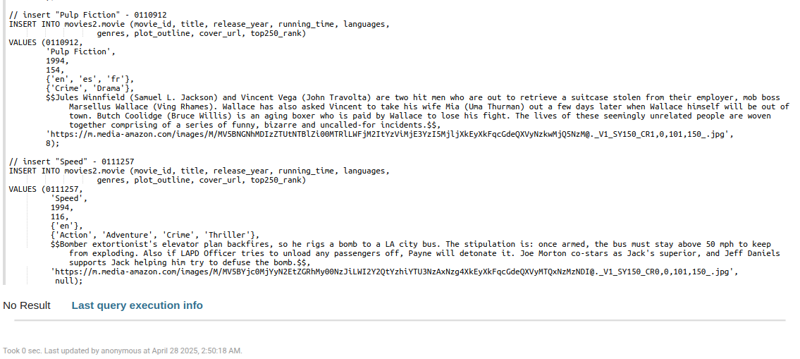

Рис.9 Добавили фильмы

Добавили актеров "Bruce Willis", "John Travolta", "Sandra Bullock", "Samuel L. Jackson", "Uma Thurman" и "Quentin Tarantino"

// insert "Bruce Willis" - 0000246

INSERT INTO movies.actor (actor_id, name, headshot_url, birth_date, trade_mark)

VALUES (0000246,

'Bruce Willis',

'https://m.media-amazon.com/images/M/MV5BMjA0MjMzMTE5OF5BMl5BanBnXkFtZTcwMzQ2ODE3Mw@@._V1_UY98_CR8,0,67,98_AL_.jpg',

'1955-03-19',

['Frequently plays a man who suffered a tragedy, had lost something or had a crisis of confidence or conscience.',

'Frequently plays likeable wisecracking heroes with a moral centre',

'Headlines action-adventures, often playing a policeman, hitman or someone in the military',

'Often plays men who get caught up in situations far beyond their control',

'Sardonic one-liners',

'Shaven head',

'Distinctive, gravelly voice',

'Smirky grin.',

'Known for playing cynical anti-heroes with unhappy personal lives']);

// insert "John Travolta" - 0000237

INSERT INTO movies.actor (actor_id, name, headshot_url, birth_date, trade_mark)

VALUES (0000237,

'John Travolta',

'https://m.media-amazon.com/images/M/MV5BMTUwNjQ0ODkxN15BMl5BanBnXkFtZTcwMDc5NjQwNw@@._V1_UY98_CR3,0,67,98_AL_.jpg',

'1954-02-18',

['Cleft chin and razor-sharp cheekbones',

'Often works some sort of dance into his roles',

'New Jersey accent',

'Black hair and blue eyes']);

// insert "Sandra Bullock" - 0000113

INSERT INTO movies.actor (actor_id, name, headshot_url, birth_date, trade_mark)

VALUES (0000113,

'Sandra Bullock',

'https://m.media-amazon.com/images/M/MV5BMTI5NDY5NjU3NF5BMl5BanBnXkFtZTcwMzQ0MTMyMw@@._V1_UX67_CR0,0,67,98_AL_.jpg',

'1964-07-26',

null);

// insert "Samuel L. Jackson" - 0000168

INSERT INTO movies.actor (actor_id, name, headshot_url, birth_date, trade_mark)

VALUES (0000168,

'Samuel L. Jackson',

'https://m.media-amazon.com/images/M/MV5BMTQ1NTQwMTYxNl5BMl5BanBnXkFtZTYwMjA1MzY1._V1_UX67_CR0,0,67,98_AL_.jpg',

'1948-12-21',

['Deep authoritative voice',

'Rebellious characters who are disliked or considered strange by others in the story',

'Often plays police officers or government officials. Both prone to intimidation or violence',

'Often plays very wise and intelligent characters with great capacities for violence',

'Frequently plays tough characters who swear a lot',

'Frequent swearing',

'Often sports a moustache or goatee in his films',

'Shaven head',

'Kangol hats',

'Often plays hotheaded characters with a fiery temper',

'Often shouts the word "motherf*****" at some point in a film',

'Frequently cast by Quentin Tarantino']);

// insert "Uma Thurman" - 0000235

INSERT INTO movies.actor (actor_id, name, headshot_url, birth_date, trade_mark)

VALUES (0000235,

'Uma Thurman',

'https://m.media-amazon.com/images/M/MV5BMjMxNzk1MTQyMl5BMl5BanBnXkFtZTgwMDIzMDEyMTE@._V1_UX67_CR0,0,67,98_AL_.jpg',

'1970-04-29',

['Long blond hair and blue eyes', 'Statuesque, model-like figure']);

// insert "Keanu Reeves" - 0000206

INSERT INTO movies.actor (actor_id, name, headshot_url, birth_date, trade_mark)

VALUES (0000206,

'Keanu Reeves',

'https://m.media-amazon.com/images/M/MV5BNjUxNDcwMTg4Ml5BMl5BanBnXkFtZTcwMjU4NDYyOA@@._V1_UY98_CR4,0,67,98_AL_.jpg',

'1964-09-02',

['Intense contemplative gaze',

'Deep husky voice',

'Known for playing stoic reserved characters']);

// insert "Quentin Tarantino" - 0000233

INSERT INTO movies.actor (actor_id, name, headshot_url, birth_date, trade_mark)

VALUES (0000233,

'Quentin Tarantino',

'https://m.media-amazon.com/images/M/MV5BMTgyMjI3ODA3Nl5BMl5BanBnXkFtZTcwNzY2MDYxOQ@@._V1_UX67_CR0,0,67,98_AL_.jpg',

'1963-03-27',

['Lead characters usually drive General Motors vehicles, particularly Chevrolet and Cadillac, such as Jules 1974 Nova and Vincents 1960s Malibu.',

'Briefcases and suitcases play an important role in Pulp Fiction (1994), Reservoir Dogs (1992), Jackie Brown (1997), True Romance (1993) and Kill Bill: Vol. 2 (2004).',

'Makes references to cult movies and television',

'Frequently works with Harvey Keitel, Tim Roth, Michael Madsen, Uma Thurman, Michael Bowen, Samuel L. Jackson, Michael Parks and Christoph Waltz.',

'His films usually have a shot from inside an automobile trunk',

'He always has a Dutch element in his films: The opening tune, Little Green Bag, in Reservoir Dogs (1992) was performed by George Baker Selection and written by Jan Gerbrand Visser and Benjamino Bouwens who are all Dutch. The character Freddy Newandyke, played by Tim Roth is a direct translation to a typical Dutch last name, Nieuwendijk. The code name of Tim Roth is Mr. Orange, the royal color of Holland and the last name of the royal family. The Amsterdam conversation in Pulp Fiction (1994), Vincent Vega smokes from a Dutch tobacco shag (Drum), the mentioning of Rutger Hauer in Jackie Brown (1997), the brides name is Beatrix, the name of the Royal Dutch Queen.',

'[The Mexican Standoff] All his movies (including True Romance (1993), which he only wrote and did not direct) feature a scene in which three or more characters are pointing guns at each other at the same time.',

'Often uses an unconventional storytelling device in his films, such as retrospect (Reservoir Dogs (1992)), non-linear (Pulp Fiction (1994)), or "chapter" format (Kill Bill: Vol. 1 (2003)).',

'His films will often include one long, unbroken take where a character is followed around somewhere.']);

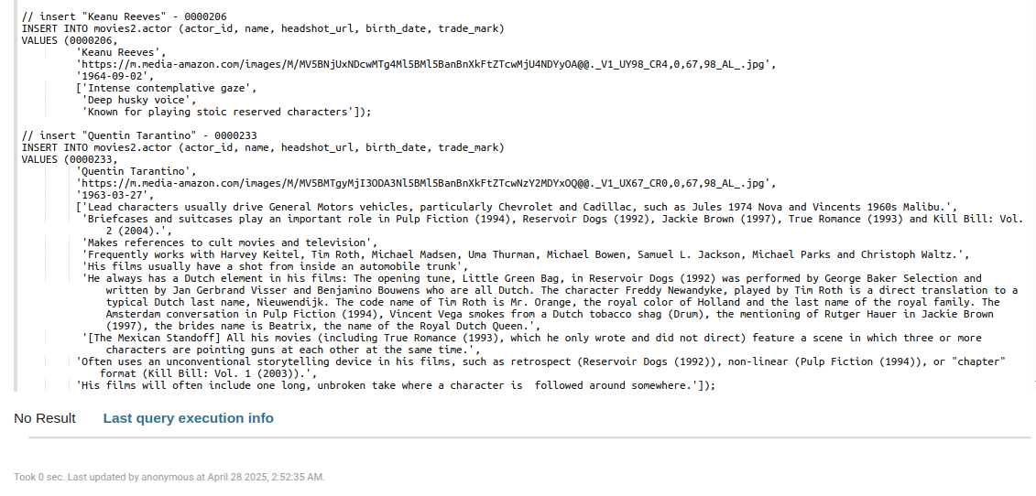

Рис.10 Добавили актеров

Создадим таблицы фильмы по актерам и актеры по фильмам

DROP TABLE IF EXISTS movies.movies_by_actor;

CREATE TABLE movies.movies_by_actor (actor_id int,

movie_id int,

title text,

PRIMARY KEY (actor_id, movie_id)

);

DROP TABLE IF EXISTS movies.actors_by_movie;

CREATE TABLE movies.actors_by_movie (movie_id int,

title text STATIC,

actor_id int,

name text,

PRIMARY KEY (movie_id, actor_id)

);

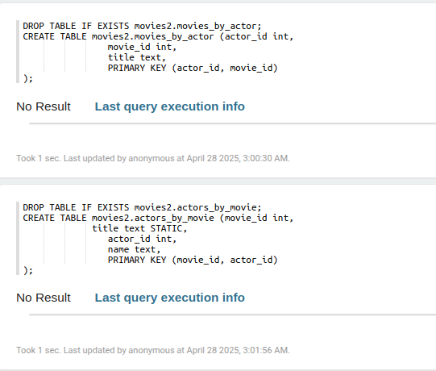

Рис.11 Создание таблиц

Добавим несколько фильмов для данных актеров.

**// Фильмы для актера "Bruce Willis"**

**INSERT INTO movies.movies_by_actor (actor_id, movie_id, title)**

**VALUES (0000246, 0110912, 'Pulp Fiction');**

**INSERT INTO movies.movies_by_actor (actor_id, movie_id, title)**

**VALUES (0000246, 1606378, 'A Good Day to Die Hard');**

**INSERT INTO movies.movies_by_actor (actor_id, movie_id, title)**

**VALUES (0000246, 0217869, 'Unbreakable');**

**INSERT INTO movies.movies_by_actor (actor_id, movie_id, title)**

**VALUES (0000246, 0377917, 'The Fifth Element');**

**INSERT INTO movies.movies_by_actor (actor_id, movie_id, title)**

**VALUES (0000246, 0112864, 'Die Hard: With a Vengeance');**

**// Фильмы для актера "Keanu Reeves"**

**INSERT INTO movies.movies_by_actor (actor_id, movie_id, title)**

**VALUES (0000206, 0133093, 'The Matrix');**

**INSERT INTO movies.movies_by_actor (actor_id, movie_id, title)**

**VALUES (0000206, 0234215, 'The Matrix Reloaded');**

**INSERT INTO movies.movies_by_actor (actor_id, movie_id, title)**

**VALUES (0000206, 0111257, 'Speed');**

**// Фильмы для актера "Sandra Bullock"**

**INSERT INTO movies.movies_by_actor (actor_id, movie_id, title)**

**VALUES (0000113, 0111257, 'Speed');**

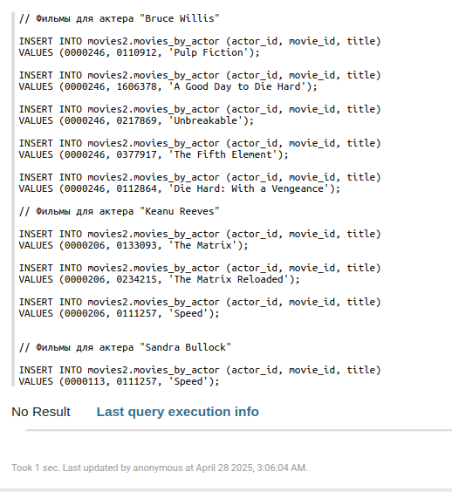

Рис.12 Добавление данных актеров

Добавим данные в таблицу actors_by_movie

**// Актеры для фильма "The Matrix"**

**INSERT INTO movies.actors_by_movie (movie_id, title, actor_id, name)**

**VALUES (0133093, 'The Matrix', 0000206, 'Keanu Reeves');**

**INSERT INTO movies.actors_by_movie (movie_id, title, actor_id, name)**

**VALUES (0133093, 'The Matrix', 0000401, 'Laurence Fishburne');**

**INSERT INTO movies.actors_by_movie (movie_id, title, actor_id, name)**

**VALUES (0133093, 'The Matrix', 0005251, 'Carrie-Anne Moss');**

**INSERT INTO movies.actors_by_movie (movie_id, title, actor_id, name)**

**VALUES (0133093, 'The Matrix', 0915989, 'Hugo Weaving');**

**// Актеры для фильма "Pulp Fiction"**

**INSERT INTO movies.actors_by_movie (movie_id, title, actor_id, name)**

**VALUES (0110912, 'Pulp Fiction', 0000237, 'John Travolta');**

**INSERT INTO movies.actors_by_movie (movie_id, title, actor_id, name)**

**VALUES (0110912, 'Pulp Fiction', 0000168, 'Samuel L. Jackson');**

**INSERT INTO movies.actors_by_movie (movie_id, title, actor_id, name)**

**VALUES (0110912, 'Pulp Fiction', 0000246, 'Bruce Willis');**

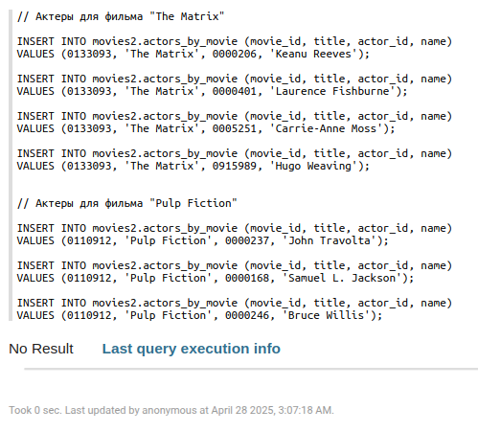 рис.13 добавление данных в actors_by_movie

Добавим рейтинги для фильма "Криминальное чтиво" используя столбцы-счетчики

**DROP TABLE IF EXISTS movies.rating_by_movie;**

**CREATE TABLE movies.rating_by_movie (movie_id int,**

**one_star counter,**

**two_star counter,**

**three_star counter,**

**four_star counter,**

**five_star counter,**

**PRIMARY KEY (movie_id)**

**);**

**UPDATE movies.rating_by_movie**

**SET five_star = five_star + 1**

**WHERE movie_id = 0110912;**

**UPDATE movies.rating_by_movie**

**SET four_star = four_star + 1**

**WHERE movie_id = 0110912;**

**UPDATE movies.rating_by_movie**

**SET five_star = five_star + 1**

**WHERE movie_id = 0110912;**

**UPDATE movies.rating_by_movie**

**SET five_star = five_star + 1**

**WHERE movie_id = 0110912;**

**UPDATE movies.rating_by_movie**

**SET two_star = two_star + 1**

**WHERE movie_id = 0110912;**

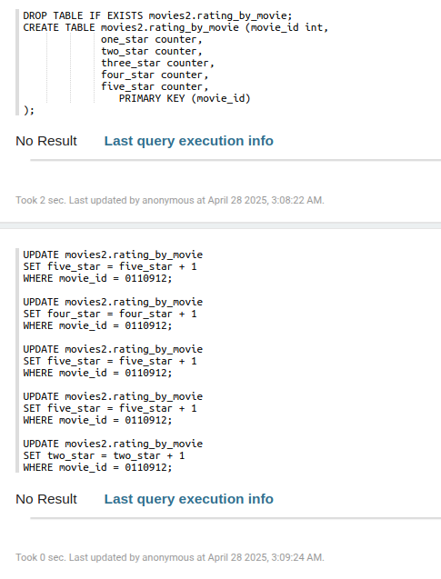

Рис.14 Добавление рейтингов

Проверка текущих рейтингов криминального чтива

**SELECT * FROM movies.rating_by_movie WHERE movie_id = 0110912;**

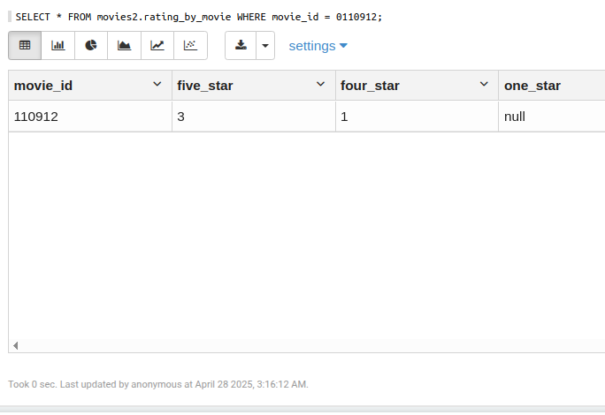

Рис.15 Проверка рейтингов криминального чтива

Cоздадим таблицу, которая подсчитывает количество просмотров каждого фильма, разделенных на зрителей-мужчин и женщин, и по месяцам

**DROP TABLE IF EXISTS movies.movie_viewed_by_time;**

**CREATE TABLE movies.movie_viewed_by_time (movie_id int,**

**year int,**

**month int,**

**male counter,**

**female counter,**

**PRIMARY KEY (movie_id, year, month)**

**) WITH CLUSTERING ORDER BY (year DESC, month DESC);**

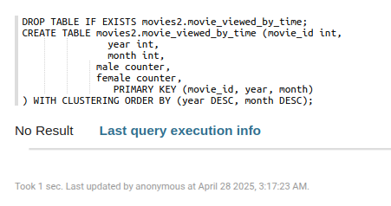

Рис.16 таблицы подсчитывает количество просмотров каждого фильма

Добавим несколько примеров значений в новую таблицу.

**// Pulp Fiction Views 2019/03**

**UPDATE movies.movie_viewed_by_time**

**SET male = male + 1**

**WHERE movie_id = 0110912 AND year = 2019 and month = 03;**

**UPDATE movies.movie_viewed_by_time**

**SET male = male + 1**

**WHERE movie_id = 0110912 AND year = 2019 and month = 03;**

**UPDATE movies.movie_viewed_by_time**

**SET female = female + 1**

**WHERE movie_id = 0110912 AND year = 2019 and month = 03;**

**// Pulp Fiction Views 2019/04**

**UPDATE movies.movie_viewed_by_time**

**SET female = female + 1**

**WHERE movie_id = 0110912 AND year = 2019 and month = 04;**

**UPDATE movies.movie_viewed_by_time**

**SET male = male + 1**

**WHERE movie_id = 0110912 AND year = 2019 and month = 04;**

**UPDATE movies.movie_viewed_by_time**

**SET female = female + 1**

**WHERE movie_id = 0110912 AND year = 2019 and month = 04;**

**UPDATE movies.movie_viewed_by_time**

**SET female = female + 1**

**WHERE movie_id = 0110912 AND year = 2019 and month = 04;**

**// Pulp Fiction Views 2019/05**

**UPDATE movies.movie_viewed_by_time**

**SET male = male + 1**

**WHERE movie_id = 0110912 AND year = 2019 and month = 05;**

**UPDATE movies.movie_viewed_by_time**

**SET male = male + 1**

**WHERE movie_id = 0110912 AND year = 2019 and month = 05;**

**UPDATE movies.movie_viewed_by_time**

**SET female = female + 1**

**WHERE movie_id = 0110912 AND year = 2019 and month = 05;**

**UPDATE movies.movie_viewed_by_time**

**SET female = female + 1**

**WHERE movie_id = 0110912 AND year = 2019 and month = 05;**

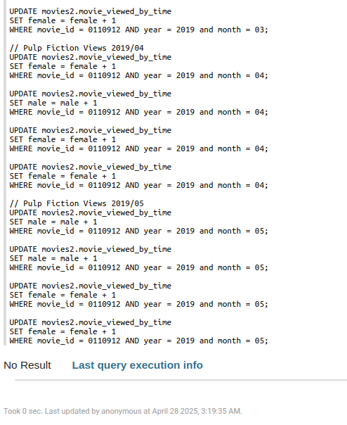

Рис.17 добавлений новых значений

Выведем просмотры фильма "Криминальное чтиво" за все время

SELECT *

FROM movies.movie_viewed_by_time

WHERE movie_id = 0110912;

Выведем просмотры фильма "Криминальное чтиво" за один месяц

SELECT *

FROM movies.movie_viewed_by_time

WHERE movie_id = 0110912 AND year = 2019 AND month = 05;

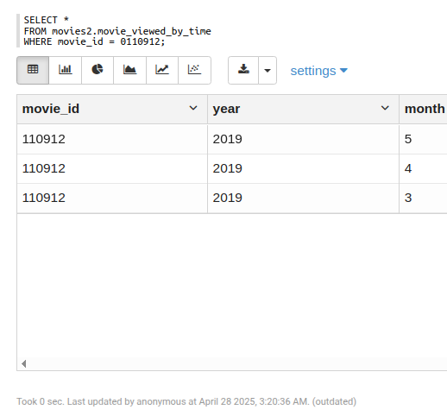

Рис.18 просмотр Криминального чтива за всё время

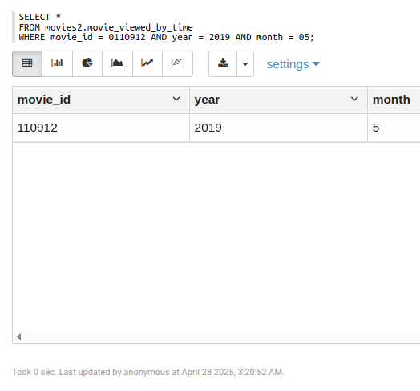

Рис.19 просмотр Криминального чтива за месяц

Выведем просмотры фильма "Криминальное чтиво" за месяц с января по май

**SELECT \***

**FROM movies.movie_viewed_by_time**

**WHERE movie_id = 0110912 AND year = 2019 AND month >= 01 AND month <= 5;**

Рис.20 Просмотры с января по май

Индивидуальное задание

Создайте ключспейс library с репликацией SimpleStrategy и коэффициентом репликации 1.

**CREATE KEYSPACE library**

**WITH replication = {'class': 'SimpleStrategy', 'replication_factor': 1};**

**DESCRIBE KEYSPACES;**

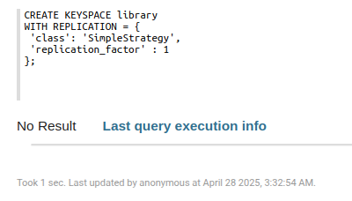

Рис.20 создание ключспейс library

**DESCRIBE KEYSPACE library;**

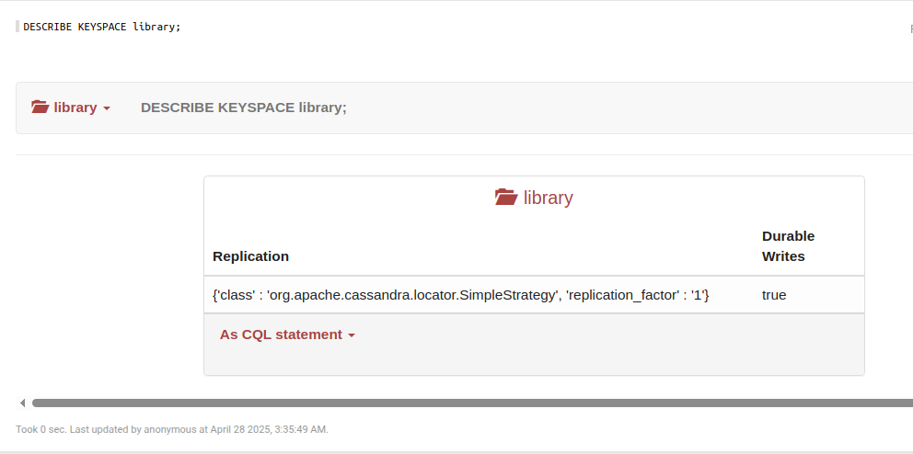

Рис.21 информация о ключспейс library

Создайте таблицу professors в ключспейсе universities с полями professor_id (int), name (text), department (text), email (text), office (text) и первичным ключом professor_id.

**CREATE TABLE library.books (**

**Book_id INT PRIMARY KEY,**

**title TEXT,**

**author TEXT,**

**year_published INT,**

**genre TEXT**

**lisbn TEXT**);

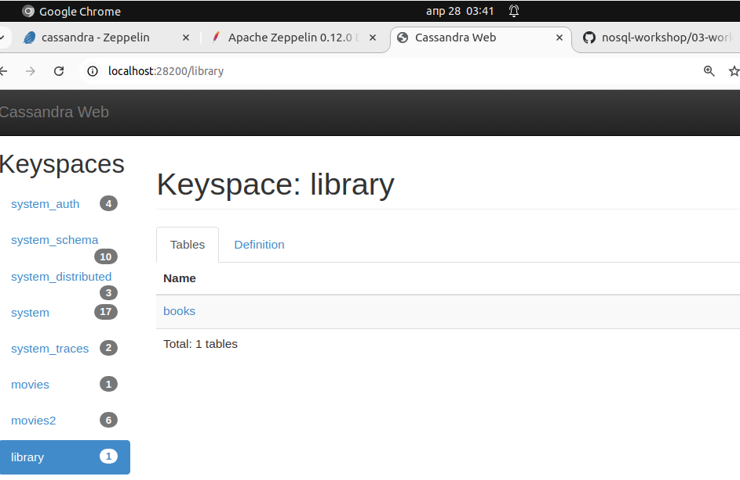

Рис.22 Создание таблицы library

Вставьте три книги в таблицу books.

**INSERT INTO library.books (book_id, title, author, year_published, genre, isbn)**

**VALUES (1, ‘A Storm of Swords’, ‘George R R MARTIN', 2000, 'Fantasy', 9780074262323);**

**INSERT INTO library.books (book_id, title, author, year_published, genre, isbn)**

**VALUES (2, 'Crooked Kingdom', ‘Leigh Bardugo',2000, ‘Fantasy’ '9785171616960');**

**INSERT INTO library.books (book_id, title, author, year_published, genre, isbn)**

**VALUES (3, 'The Shawshank Redemption', ‘Stephen King', 2011, ‘Thriller', '9785219290');**

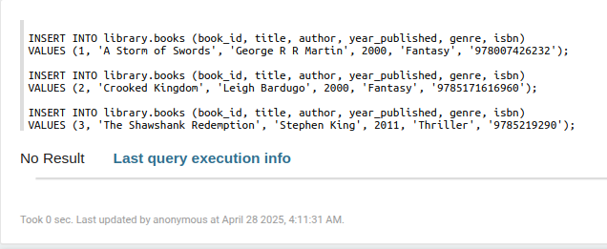

Рис.23 добавление информации о профессорах

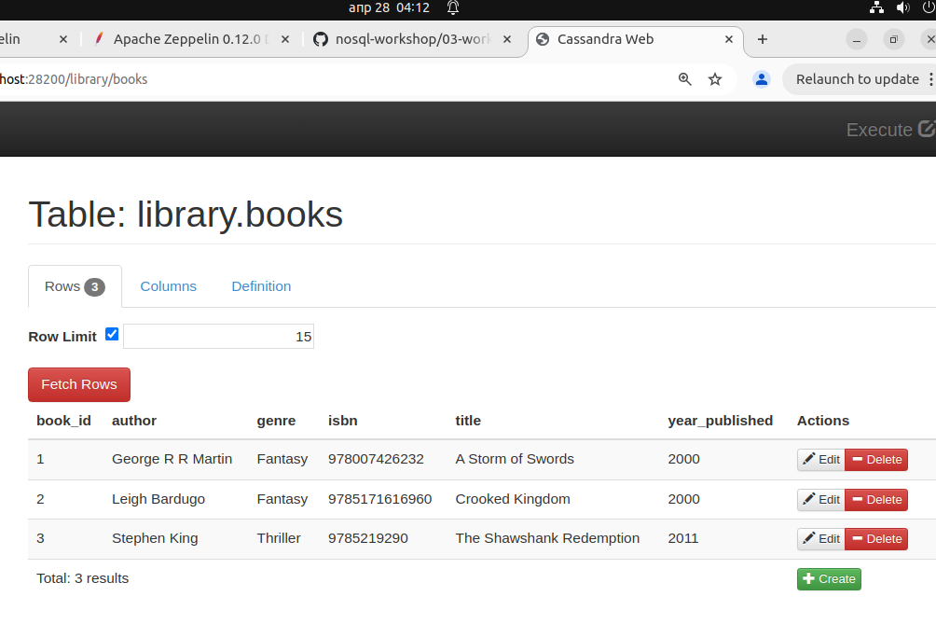

Рис.24 добавление информации о книгах

Выберите все книги из таблицы books.

**SELECT * FROM library.books;**

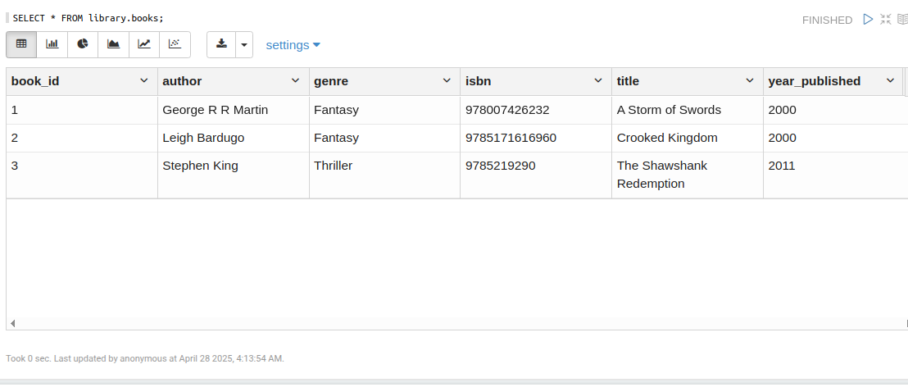

Рис.25 вывод всех книг

Обновите поле office профессора с professor_id = 3.

**UPDATE library.books**

**SET year_published = 1962**

**WHERE book_id = 1;**

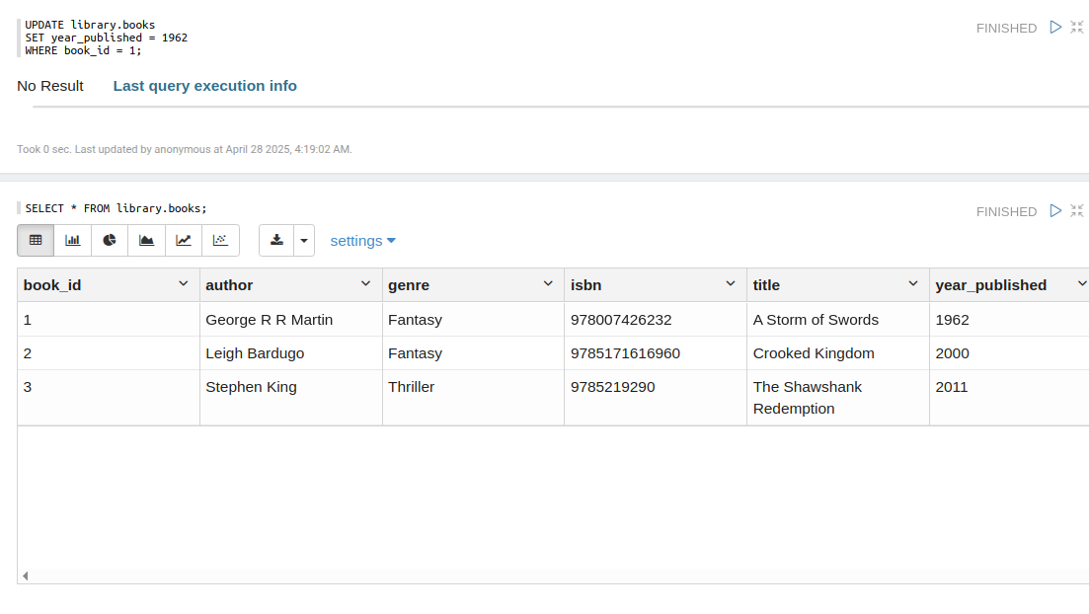

Рис.26 обновление поля первой книги

Заключение

После выполнения лабораторной работы, были получены практические навыки работы с базой данных Cassandra, изучены основные операции по управлению данными, включая создание и использование ключспейсов, таблиц, выполненены запросов CQL, а также работа с различными инструментами подключения и администрирования.